Chemical Kinetics
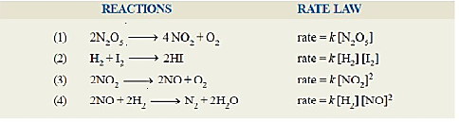
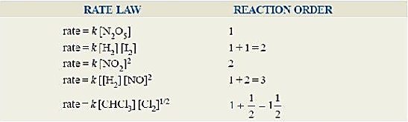
1. Reaction Rate Law order find:

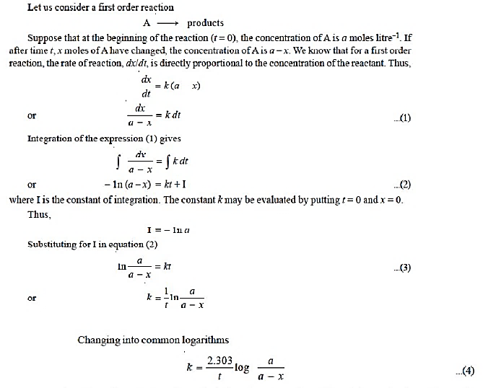
2. Derive integrated rate equation of a first order reaction.

3. Rate constant of a first order reaction is 250 s-1. Calculate the half-life of the reaction.
We know,
For a first-order reaction, the half-life formula is: t_{1/2} = 0.693/k
Given:
k=250 S⁻¹
Now, t ^{1/2} = 0.693 / 250
t ^{1/2} = 0.002772 s
t ^{1/2} = 2.77 x 10⁻³
So, the half life of the reaction is 2.77 x 10⁻³ seconds.
4. Define Colloid. Explain Tyndall effect with figure.
The word colloid comes from a Greek word “Kola”. A colloid is a substance microscopically dispersed throughout another substance.

Explain Tyndall:
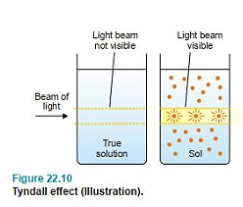
The phenomenon of the scattering of light by the sol particles is called Tyndall effect.
The illuminated beam or cone formed by the scattering of light by the sol particles
is often referred as Tyndall beam or Tyndall cone. The hazy illumination of the light
beam from the film projector in a smoke-filled theatre or the light beams from the
headlights of a car on a dusty road, are familiar examples of the Tyndall effect. True
solutions do not show Tyndall effect. Thus Tyndall effect can be used to distinguish
a colloidal solution from a true solution.

5. Write the name of disperse phase, dispersion medium and two example of the following colloidal states: foam, aerosol, emulsion, smoke, sol.
Type Name | Disperse phase | Dispersion Medium | Example
Foam | gas | liquid | Whipped cream, shaving cream, soda-water
Aerosol | liquid | gas | For, mist, clouds
Emulsion | liquid | liquid | Milk, hair cream
Smoke | solid | gas | Dust, soot in air
Sol | solid | liquid | Paint, ink, colloidal gold

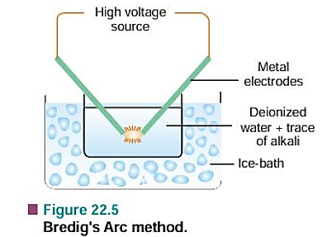
6. Discuss Bredig’s arc method with figure.
i. Bredig’s arc method is used to prepare metal sols like gold and silver.
ii. Two metal electrodes are placed in cold deionized water.
iii. A high voltage arc is passed between the electrodes.
iv. The heat changes metal into vapour, and it cools to form tiny
particles in water.
v. These tiny particles spread in water and form a colloidal solution.
vi. Non-metal sols can be made by suspending in the dispersion medium
and striking an acr between iron electrodes.

Colligative Properties
7. i. Define Colligative properties.
A colligative property may be defined as one which depends on the number of particles in solution and not in any way on the size or chemical nature of the particles.

ii. Define Raoult’s Law.
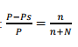
The relative lowering of the vapour pressure of a dilute solution is equal to the mole fraction of the solute present in dilute solution.
Raoult’s Law can be expressed mathematically in the form

8. Explain elevation of the boiling point of solution and depression of the freezing point of a solvent in a mixture.
A liquid boils when its vapour pressure becomes equal to atmospheric pressure. Adding a non-volatile solute lowers the vapour pressure of the liquid. So, the solution needs more heat to boil, and its boiling point increases. the difference in the boiling points (ΔT) is called the elevation of boiling point. T-Tb = ΔT
The vapour pressure of a pure liquid changes with temperature as shown by the curve ABC, in Fig. 3. There is a sharp break at B where, in fact, the freezing-point curve commences. Thus the point B corresponds to the freezing point of pure solvent. the solution is referred to as the Depression of freezing point. It is represented by the symbol ΔT or ΔTf .
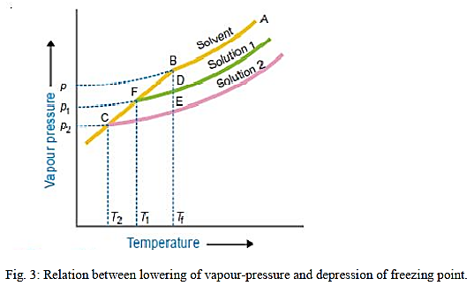
Tf - T1 = ∆T

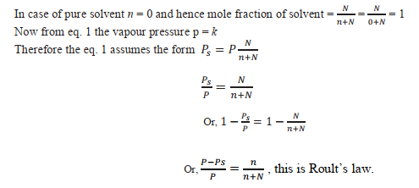
9. Deduce the equation P-Ps/P = n/n+N from lowering of vapour pressure of a solvent in a mixture.

10. Calculate the vapour pressure lowering caused by the addition of 100 g of sucrose (mol mass = 342) to 1000 g of water if the vapour pressure of pure water at 25°C is 23.8 mm Hg.


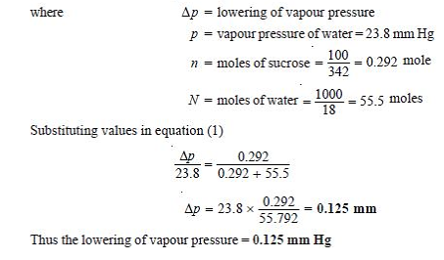

Thermo Chemistry
11. What is thermochemistry?
The branch of physical chemistry which deals with the thermal or heat changes caused by chemical reactions is called thermochemistry
12. Exothermic reactions VS Endothermic reactions
Exothermic reactions | Endothermic reaction
1. An exothermic reaction is a reaction in which heat is released by the system to the  surroundings. From the perspective of the system, “heat is given off.” | 1. An endothermic reaction is a reaction in which heat is absorbed by the system from the surroundings. From the perspective of the system, “heat is taken in.”
2. For an exothermic reaction, the sign of ΔH is negative | 2. For an endothermic reaction, the sign of ΔH is positive
3. When a reaction is exothermic (ΔH is negative), that is a favorable condition. | 3. When a reaction is endothermic (ΔH is positive), that is an unfavorable condition.
4. ∆H = heat of product – heat of reactant = 100 kj – 110 kj = -10 kj | 4. ∆H = heat of product – heat of reactant = 100 kj – 90 kj = +10 kj

13. Thermochemical equation with an example
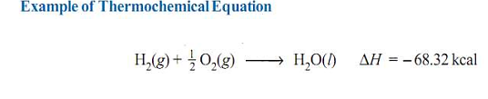
An equation which indicates the amount of heat change in the reaction or process is called a Thermochemical equation.

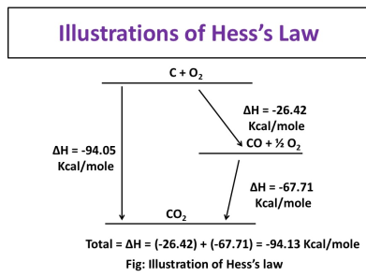
14. Hess’s Law -> this statement and application.
Statement: The total heat change of a chemical reaction is always the same,
no matter how many steps the reaction takes.

Applications of Hess’s law
1. Determination of heat of formation of substances which otherwise cannot be measured
experimentally.
2. Determination of heat of transition.
3. Determination of heat of various reactions.

Atomic Structure
15. Describe Bohr model of the atom and write its limitation.
i. Concept of stationary orbit or Energy levels of Electrons
ii. Absorption or Emission of Energy and concept of Spectrum
iii. Postulate Concerning Angular momentum: the angular momentum of the electron is an integral multiple of h/2π.
Limitations of the Bohr’s Atom Model:
i. Though Bohr’s Atom model can explain the Hydrogen atom spectrum
ii. Bohr’s atom model can’t explain how these fine multiple lines are formed in the atomic spectra.
iii. According to Bohr’s model electrons revolve in circular orbits but modern research reveals that electrons revolve three-dimensionally
iv. Bohr’s theory improved the atom model, it failed and measurably failed to explain the atom satisfactorily.

16. Define quantum number and explain there four types.
The number, that expresses the size, shapes, and direction of the orbital from the nucleus and the spins of the electron of their own axes, are called quantum numbers.
There are four types of quantum numbers:
1. Principal quantum number (n)
2. Subsidiary quantum number (l)
3. Magnetic quantum number (m)
4. Spin quantum number (s)
Explain There are four type of quantum numbers:
1. Principal quantum number “n”
This quantum number denotes the principal shell to which the electron belongs. This is also referred to as major energy level. The principal quantum number ‘n’ can have non-zero, positive, integral values n = 1, 2, 3... increasing by integral numbers to infinity. The letters K, L, M, N, O, P and Q are also used to designate the energy levels or shells of electrons with a n value of 1, 2, 3, 4, 5, 6, and 7 respectively. the same principal quantum number and is given by 2n²
Principal quantum number (n =) 1 2 3 4
Letter designation K L M N
Maximum number of electrons (2n2 = ) 2 8 18 32

2. Subsidiary quantum number (l)
The quantum number l defines the shape of the orbital occupied by the electron and the angular momentum of the electron. It is for this reason that ‘l’ is sometimes referred to as an orbital or angular quantum number. the azimuthal quantum number l may have all integral values from 0 to ‘n – 1’, each of which refers to an Energy sublevel or Sub-shell.

3. Magnetic quantum number (m)
This quantum number has been proposed to account for the sapling up of spectral lines (Zeeman Effect). This is also called the Orientation Quantum Number because it gives the orientation or distribution of the electron cloud.

4. Spin quantum number (s)
This quantum number has been introduced to account for the spin of electrons about their axis. there are two values given to s ; 1 /2 + and 1/ 2 – depending upon whether the electron spins in one direction or the other. These spins are also designated by arrows pointing upwards and downward ↓↑.

17. What is the significance of de Broglie equation?
de Broglie had arrived at his hypothesis with the help of Planck’s Quantum Theory and Einstein’s Theory of Relativity. According to Planck, the photon energy ‘E’ is given by the equation
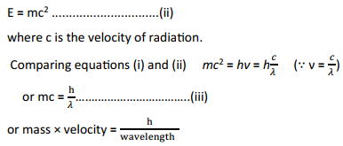
E = hν ..................................(i)

The equation (iii) is called de Broglie’s equation.

